**Influence of Minority Demographics on Computer Science Participation in Los Angeles County Public Schools**

**Abstract**

This study looked at California Department of Education enrollment records for all 536 Los Angeles County Public High Schools to determine the influence of ethnicity, gender and income on a school’s participation in Computer Science (C.S.). We tested the assumption that schools with higher minority and low-income populations would be less likely to offer C.S., and that students at those schools would be less likely to enroll in a C.S. course if offered.

**Introduction**

The motivation behind this study was to determine which demographic categories are more or less predisposed to participate in C.S. Current and on-going studies have shown that typically underserved minority groups are especially underrepresented in K-12 C.S. classes[1]. Ethnic minorities, low-income students and female students face structural and social barriers in their K-12 education, leading to the diversity gap seen in C.S. graduates and professionals. These students lack access to the technologies needed to support C.S. at home and in the classroom, and therefore see disproportionately fewer C.S. courses at their schools. Studying a school zone as diverse as Los Angeles County gives insight into how these patterns translate when the schools are composed of higher proportions of minority students than is observed nationally. Thus we gain a new perspective from which to judge the influence of structural barriers versus social ones.

**Project Description**

School and course enrollment data for the 2014-2015 schoolyear was found on the California Department of Education’s (CDE) Staff Assignment and Course Data page[2]. The school data contained student enrollment by ethnicity, grade level, and gender. Ethnicities included African American, Asian, Hispanic, White, and Other (American Indian, Filipino, Pacific Islander, No Ethnicity Reported, and Two or More Ethnicities Reported). The course enrollment data contained the same information but at course-level (e.g. AP Computer Science A). The school data was filtered by county and grade level to only store information about Los Angeles County Public High Schools, and course data was filtered by course code to only store enrollment information for C.S.-related courses.

The schools’ income level was measured by the percentage of students eligible for Free and Reduced-Price Meals (FRPM), since eligibility is based on family income. This data was found on the CDE’s Student Poverty FRPM Data page[3] for each school for the 2014-2015 schoolyear. The FRPM data was appended to their respective schools in the aforementioned school data table. The economic criteria for eligibility and participation in the FRPM is available at the USDA Food and Nutrition Service Income Eligibility Guidelines page [4]. We will analyze schools based on the percentage of their students who qualify for FRPM, so we will refer to these schools by tiers, which are mapped in Table 1.

|  |  |
| --- | --- |
| % of School FRPM-Eligible | Tier |
| 0 – 20% FRPM-Eligible | Tier 1 |
| 20 –40% FRPM-Eligible | Tier 2 |
| 40 – 60% FRPM-Eligible | Tier 3 |
| 60 – 80% FRPM-Eligible | Tier 4 |
| 80 – 100% FRPM-Eligible | Tier 5 |

**Table 1: Map of Tiers to reference schools by percent of FRPM-eligible students**

The data tables populated identical tables created in a database so that we could run analytical queries on them and eventually share the data with others. These queries revealed school-level demographic data, i.e. the distribution of ethnicities and genders at the schools, and how many schools belonged to each income tier. These queries were repeated for only schools that offered C.S., so that we could see what factors set them apart from the rest of the county. Next, we wrote queries to extract course-level demographic data for schools that offered C.S., i.e. the distribution of ethnicities and genders among C.S. students, and the proportion of C.S. students that attended schools in each income tier.

**Results**

In total, 93 of the 536 public high schools studied offered any Computer Science courses.

The overall ethnic distribution of LA County Public High Schools was as follows: 65.9% Hispanic, 14.3% White, 8.5% Asian, 8.2% African American. The distribution of schools by the percentage of their students who were FRPM-eligible was: 6.0% Tier 1, 6.3% Tier 2, 17.0% Tier 3, 34.1% Tier 4, 36.6% Tier 5. The gender distribution was 51.5% Male, 48.5% Female.

81.5% of schools had populations where the majority of students were FRPM-eligible.

Income

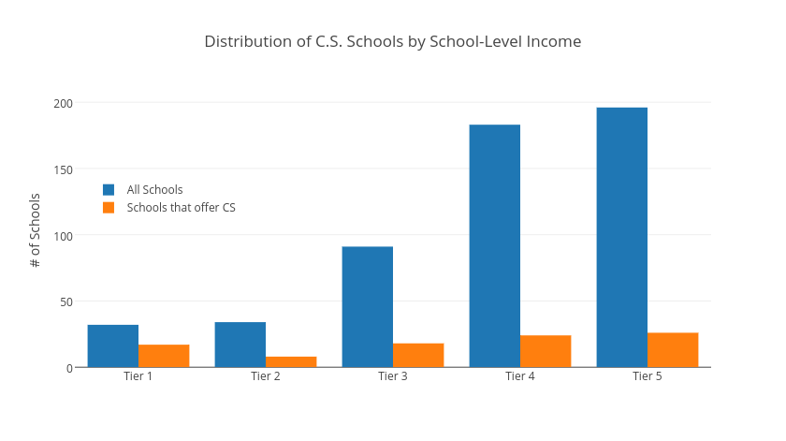

**Figure 1: Distribution of C.S. Schools by Tiers**

Figure 1 shows the disproportionate number of Tier 4 and Tier 5 schools, and the overall low number of C.S. schools.

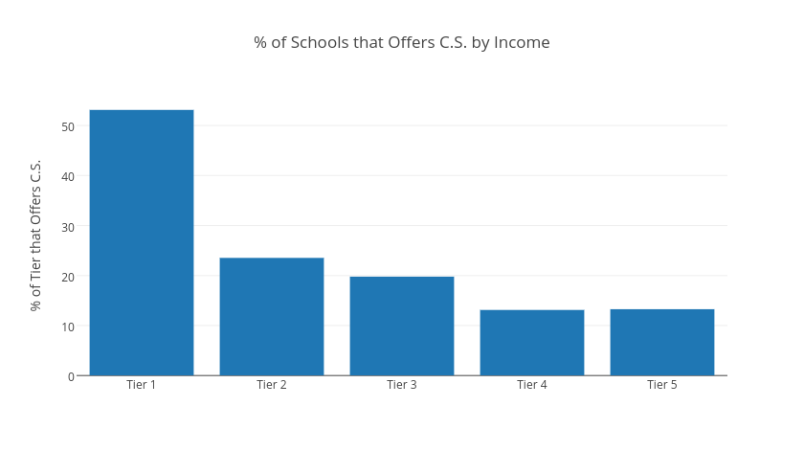

**Figure 2: Percentage of Schools that Offer C.S. by Tiers**

Figure 2 plots the percentage of each tier that offers C.S. We note a general decline from tier to tier, but an especially large difference between Tier 1 and all other Tiers. Of these Tier 1 schools, 53.1% offered C.S., whereas only 10.9% and 13.3% of schools offered it in the Tier 4 and Tier 5 schools, respectively. Thus Tier 1 schools were 387% and 292% more likely to offer C.S. than those schools. We can say that generally less income leads to less likelihood of offering C.S., but it is unclear how big of a factor this is, since Tier 2 – 5’s percentages are roughly similar.

|  |  |  |  |  |  |
| --- | --- | --- | --- | --- | --- |
| Tier | Total Students | C.S. Students | % of Tier Enrolled in C.S. | % of All Students in this Tier (C.S. Schools) | % of C.S. Students in this Tier |
| Tier 1 | 32,110 | 1,541 | 4.8% | 19.4% | 18.0% |
| Tier 2 | 17,479 | 512 | 2.9% | 10.6% | 6.0% |
| Tier 3 | 29,777 | 1,899 | 6.4% | 18.0% | 22.2% |
| Tier 4 | 43,425 | 1,693 | 3.9% | 26.3% | 19.8% |
| Tier 5 | 42,368 | 2,904 | 6.9% | 25.7% | 34.0% |

**Table 2: Distribution of C.S. students by Tier**

Table 2 presents student-level enrollment data by tier, summarized in Figure 2. We note that Tiers 3 and 5 have a 33.3% and 43.8% bigger proportion of their students enrolled in C.S. than Tier 1, respectively. Tier 2’s proportion is also smaller than all lower-income tiers. This indicates that Tier 1 and Tier 2 students may be less inclined to enroll in C.S. than these lower-income tiers.

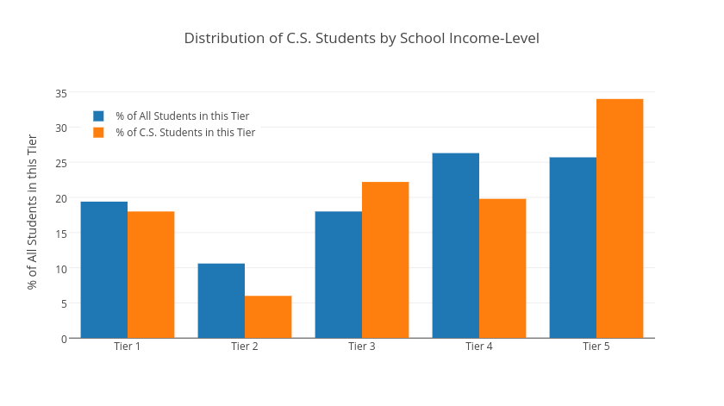

**Figure 2: Distribution of C.S. Students by Tiers**

In Figure 2 we see that although Tier 1 schools accounted for only 6.0% of all LA County schools, they accounted for 19.4% of the students in LA county and 18.0% of schools that offer C.S. However, Tiers 3, 4, and 5 all had higher shares of the C.S. student population than Tier 1, even though their shares of the overall student population was not significantly higher than Tier 1’s. This suggests that income may not be directly related to a student’s decision to enroll in a C.S. course when offered, as we had hypothesized.

Still, the high rate at which higher-income schools offer C.S. has a large impact as to which ethnicities have access to C.S. courses, as higher-income schools have radically different ethnic make-ups than lower-income schools.

Ethnicity

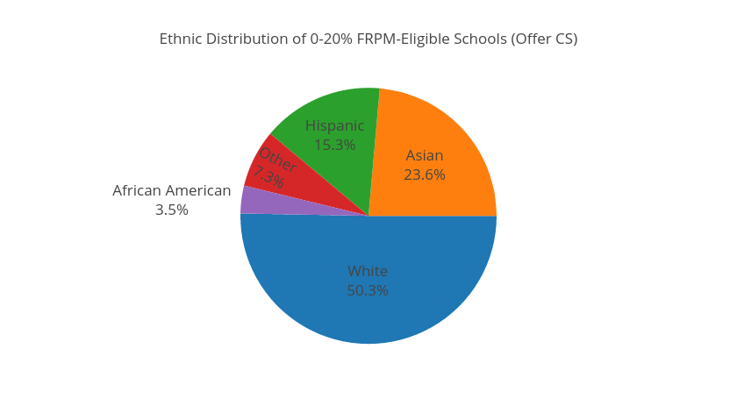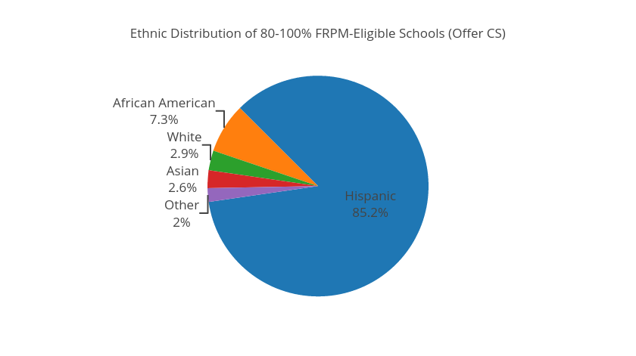

**Figure 4.a: Ethnic Distribution of Tier 1 Schools Figure 4.b: Ethnic Distribution of Tier 5 Schools**

Of the schools that offer C.S., Tier 1 schools are composed of 73.0% majority and 18.8% minority students, whereas the Tier 5 schools are 5.5% majority and 92.5% minority students.

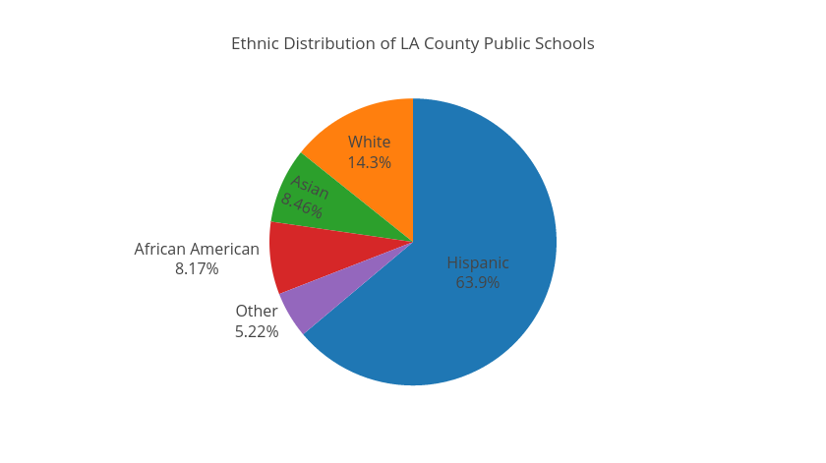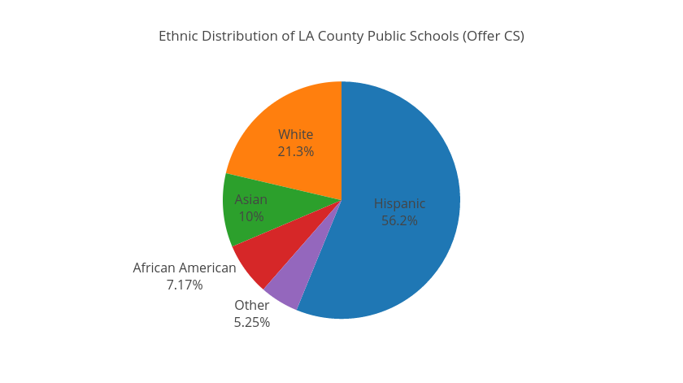

**Figure 5.a: Ethnic Distribution of All Schools Figure 5.b: Ethnic Distribution of C.S. Schools**

The effect can be seen in Figure 5.b. C.S. schools have 7.1% more White students and 7.7% fewer Hispanic students than the overall LA County distribution.

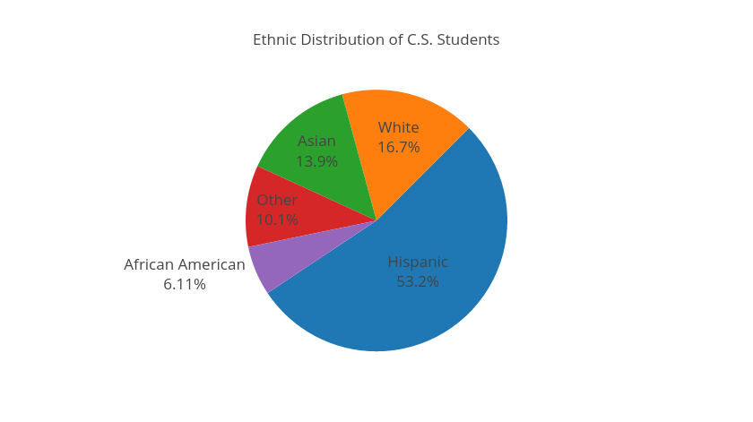

**Figure 6: Ethnic Distribution of C.S. Students**

Despite the increases in school-level representation, White students dropped 4.6% in class-level representation, and Asian students dropped 3.9% (Figure 6).

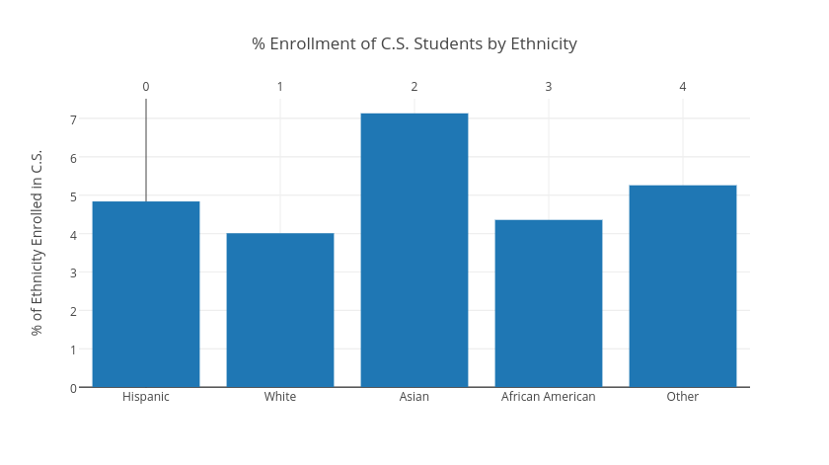

**Figure 7: Percentage of Ethnicities Enrolled in C.S.**

Gender

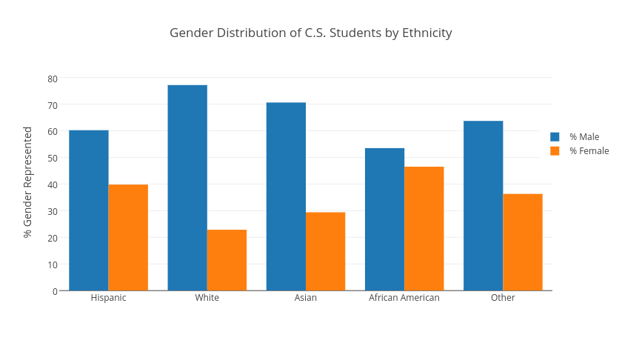

**Figure 8: Gender Distribution of C.S. Students by Ethnicity**

Figure 8 shows the stark difference in enrollment rates between White and Asian females when compared to other ethnicities. Overall, females belonging to a minority ethnicity were enrolled in C.S. at much higher proportions than their majority counterparts.

|  |  |  |  |  |
| --- | --- | --- | --- | --- |
| Ethnicity | # Male C.S. Students | # Female C.S. Students | % Male C.S. Students | % Female C.S. Students |
| Hispanic | 2704 | 1787 | 60.2% | 39.8% |
| White | 1091 | 323 | 77.2% | 22.8% |
| Asian | 831 | 346 | 70.6% | 29.4% |
| African American | 276 | 240 | 53.5% | 46.5% |
| Other | 542 | 309 | 63.7% | 36.3% |

**Table 3: Gender Distribution of C.S. Students by Ethnicity**

Hispanic females made up a 74.2% greater percentage of total CS enrollment than White females, and 35.3% greater percentage than Asian females. More noteworthy, African American females made up 103.6% greater percentage of total CS enrollment than White females, and a 58.2% greater percentage than Asian females.

Overall, females CS students were 57.0% more likely to come from a minority background (40.5% F/59.5% M) than a majority one (25.8% F/74.2% M).

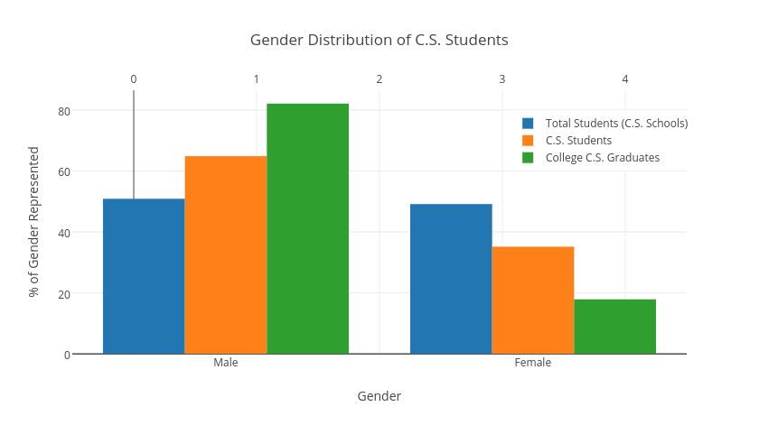

**Figure 9: Gender Distribution of C.S. Students**

In total, 23.7% of all CS students were minority females – over four times the number of minority females that graduate college with a CS degree (5.1%[5]). Figure 9 illustrates this declining trend in C.S. participation as females progress in their education.

**Conclusion**

* Mention the steady decline in Figure 2 which proves part of our hypothesis
* Table 2 shows that higher-income schools do not have higher rates of C.S. enrollment. If resources aren’t the issue, C.S. could be offered at most schools, because the rates of enrollment are uniform. That is, the inclination to enroll when offered is independent of income.
* Figure 7 shows equal C.S. participation among all ethnicities (with Asian a bit higher)
* Understanding this relationship is key if schools, universities, and companies are to target and grow underrepresented categories.

**References**

1. <https://services.google.com/fh/files/misc/searching-for-computer-science_report.pdf>
2. <http://www.cde.ca.gov/ds/sd/df/filesassign.asp>
3. <http://www.cde.ca.gov/ds/sd/sd/filessp.asp>
4. <https://www.fns.usda.gov/school-meals/income-eligibility-guidelines>
5. https://www.nsf.gov/statistics/2017/nsf17310/digest/fod-minorities/degree-share.cfm